A PROJECT REPORT

ON

OBJECT DETECTION

Submitted to

KIIT Deemed to be University

In Partial Fulfilment of the Requirement for the Award

BACHELOR’S DEGREE IN INFORMATION TECHNOLOGY ENGINEERING

By

Aditya Sinha 1706005

Aishwarya Aditya 1706007

Mainak Basu Roy 1706049

Jishnu Dey 1706508

UNDER THE GUIDANCE OF

Prof: Hrudaya Kumar Tripathy



SCHOOL OF COMPUTER ENGINEERING

**KALINGA INSTITUTE OF INDUSTRIAL TECHNOLOGY**

**Bhubaneshwar, ODISHA 751024**

**APRIL 2020**

A PROJECT REPORT

ON

OBJECT DETECTION

Submitted to

KIIT Deemed to be University

In Partial Fulfilment of the Requirement for the Award

BACHELOR’S DEGREE IN INFORMATION TECHNOLOGY ENGINEERING

By

Aditya Sinha 1706005

Aishwarya Aditya 1706007

Mainak Basu Roy 1706049

Jishnu Dey 1706508

UNDER THE GUIDANCE OF

Prof: Hrudaya Kumar Tripathy



SCHOOL OF COMPUTER ENGINEERING

**KALINGA INSTITUTE OF INDUSTRIAL TECHNOLOGY**

**Bhubaneshwar, ODISHA 751024**

**APRIL 2020**

**KIIT Deemed to be University**

**School of Computer Engineering**

**Bhubaneshwar, ODISHA 751024**

# CERTIFICATE

This is to certify that the project entitled

**“OBJECT DETECTION”**

**Submitted by:**

Aditya Sinha 1706005

Aishwarya Aditya 1706007

Mainak Basu Roy 1706049

Jishnu Dey 1706508

is a record of Bonafide work carried out by them, in the partial fulfilment of the requirement for the award of Degree of Bachelor of Engineering (Information Technology) at KIIT Deemed to be university, Bhubaneswar. This work is done during year 2019-2020, under our guidance.

Date: 24-4-2020 Prof. Hrudaya Kumar Tripathy

Project Guide

**ACKNOWLEDGEMENT**

We are profoundly grateful to Prof. HRUDAYA KUMAR TRIPATHY for his expert guidance and encouragement throughout to see that this project rights its target since its commencement to its completion. The work is a team effort minus which the completion of this project was not possible.

Aditya Sinha

Aishwarya Aditya

Maink Basu Roy

Jishnu Dey

**ABSTRACT**

In this project, we are provided with an image and asked to detect the objects present in the image and classify them according to their classes. For this we have to select the best model. This project aims to incorporate state-of-the-art technique for object detection with the goal of achieving high accuracy with a real-time performance. For this we are using DarkNet YOLO pre-trained neural network that is used to recognize multiple objects in the same image. The pre-trained dataset and weights are from YOLO V3.

Keywords: YOLO (You only look once), COCO (Common Objects in Context), DarkNet, R-CNN, Fast R-CNN, Faster R-CNN, ROL(Region of Interest) DSSD(Deconvolution Single Shot Detection),PASCAL(Pattern Analysis, Statistical modelling and Computational Learning), VGG(Visual Geometry Group).

**CONTENT**

Topic Page No

1. Introduction………………………………………………………………………………………………………………………………………….7
   1. Background…………………………………………………………………………………………………………………………………....8
2. Literature Survey…………………………………………………………………………………………………………………………………..9
   1. Object Detection……………………………………………………………………………………………………………………………..9
   2. Background Subtraction………………………………………………………………………………………………………………….10
   3. Template Matching…………………………………………………………………………………………………………………………10
3. Software Requirements Specification…………………………………………………………………………………………………….11
   1. Purpose…………………………………………………………………………………………………………………………………………..11
   2. Intended Audience………………………………………………………………………………………………………………………….11
   3. User Requirements………………………………………………………………………………………………………………………….11
4. Objective……………………………………………………………………………………………………………………………………………….12-16
   1. Existing Models……………………………………………………………………………………………………………………………….16
5. Performance of models and selection……………………………………………………………………………………………………17
   1. Why YOLO? …………………………………………………………………………………………………………………………………….18
   2. How does YOLO work? ……………………………………………………………………………………………………………………18-19
   3. Model Training…………………………………………………………………………………………………………………………………20
6. Problem Statement………………………………………………………………………………………………………………………………..20
7. Project Methodology………………………………………………………………………………………………………………………………20

7.1 Methodology used to analyse the above problem…………………………………………………………………………….21

7.2 Reduction in Time……………………………………………………………………………………………………………………………..21

1. Definitions and Tools Used………………………………………………………………………………………………………………………22
   1. Convolution Layer……………………………………………………………………………………………………………………………..22-24
   2. System Requirements………………………………………………………………………………………………………………………..25
   3. Tools Used………………………………………………………………………………………………………………………………………..25
2. Implementation……………………………………………………………………………………………………………………………………….26
   1. Steps………………………………………………………………………………………………………………………………………………….26
   2. Source code……………………………………………………………………………………………………………………………………….27
3. Performance Measure Of Models……………………………………………………………………………………………………………..28
4. Results and Conclusion……………………………………………………………………………………………………………………………..29
   1. Snapshots………………………………………………………………………………………………………………………………….29-31
   2. Future Scope………………………………………………………………………………………………………………………………..32
   3. Conclusion……………………………………………………………………………………………………………………………………33
5. References……………………………………………………………………………………………………………………………………………....34
6. Sample Individual Contribution…………………………………………………………………………………………………………………35

**Introduction**

In the year 1826, first photograph was captured by Joseph Nicéphore Niépce. The photograph that he captured was composed of black and white shades. What Mr. Niepce concocted was a small piece of polished pewter which he then coated with a solution of bitumen and lavender oil. Bitumen is a naturally occurring asphalt and is sometimes referred to as Bitumen of Judea.

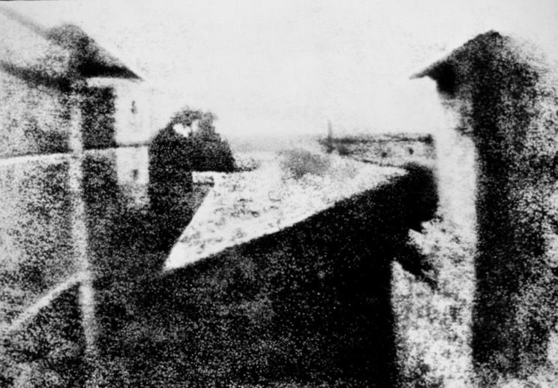 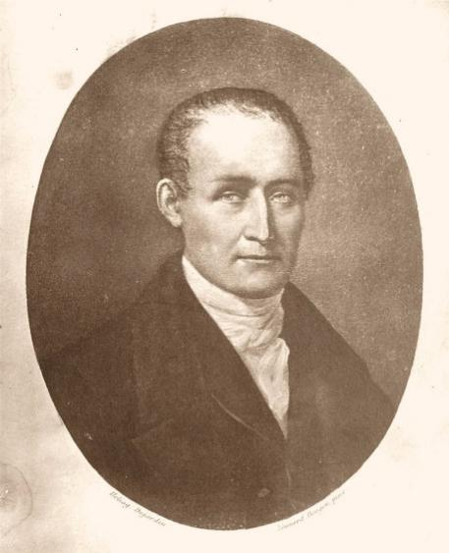

After more than one and a half century of evolution the photography industry has evolved to a great extent. The digital images these days are composed of small bits of data known as pixels. Major advancements in Artificial Intelligence has led to development of software like Self Driving Cars, Facial Recognition etc. For all these software developments, Image classification is involved. There are various models to detect objects.

Object recognition is used to describe a collection of related computer vision tasks that involve activities like identifying objects in digital photographs. Image classification involves activities such as predicting the class of one object in an image. Object localization is referred to as identifying the location of one or more objects in an image and drawing an bounding box around their extent. Object detection does the work of combining these two tasks and localizing and classifying one or more objects in an image. When a user or practitioner refers to the term “object recognition”, they often mean “object detection”. It may be challenging for beginners to distinguish between different related computer vision tasks.

**1.1 Background**

The main aim of object detection is to detect all instances of objects from a known class, such as people,

Cars, animals, table or chair in an image. Usually only a small number of instance of objects are present in image but there is a possibility that large number of them might be present. All detected objects are reported in the form of pose information like location, size and extent of object in terms of rectangular boxes around them. In some cases, pose information contains some extra details like the parameters of a linear or non-linear transformation. For example, in self driving cars detection of a car may contain the location of head lights, windscreen and tyres. An example of such is given below of a bicycle:

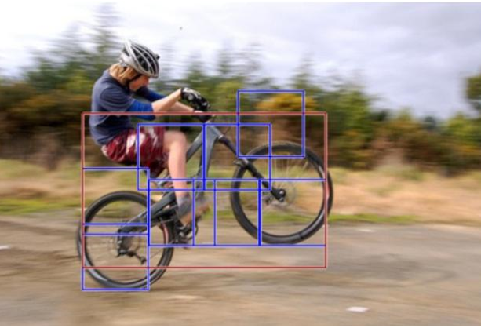

Figure 1.

The pose can also be defined by a three-dimensional transformation specifying the location of the object relative to the camera. What Object detection systems do is that they always construct a model for an object class from a set of training examples provided by thousands of images. Here in case of this bicycle multiple bicycle images were processed to define the general shape of a bicycle with individual components like tyres, seat handle, etc. In case of non-rigid objects multiple images are required in their different forms but if the object is rigid then only one picture can work. But for better training and better class variability rigid object classes also contain multiple images.

**Literature Survey**

In various fields, there is a necessity to detect the target object and also track them effectively while handling occlusions and other included complexities. Many researchers (Almeida and Guting 2004, Hsiao-Ping Tsai 2011, Nicolas Papadakis and Aure lie Bugeau 2010 ) attempted various approaches in object tracking and detection. The nature of the techniques largely depend on the application domain. Some of the research works which made the evolution to proposed work in the field of object tracking are depicted as follows:

2.1 Object Detection

This is the most important task, yet challenging vision task. It is part of image search, scene understanding and object tracking. Moving object tracking of video image sequences was one of the most important subjects in computer vision. It had already been applied in many computer vision fields, such as smart video surveillance, artificial intelligence, military guidance, safety detection and robot navigation, medical and biological application. In recent years, a number of successful single-object tracking system appeared, but in the presence of several objects, object detection becomes difficult and when objects are fully or partially occluded, they are obtruded from the human vision which further increases the problem of detection. Decreasing illumination and acquisition angle. The proposed MLP (Multilayer Perceptron) based object tracking system is made robust by an optimum selection of unique features and also by implementing the Adaboost strong classification method.

2.2 Background Subtraction

The background subtraction method is able to cope with local illumination changes, such as shadows and highlights. In this method, the background model was statistically modelled on each pixel. Computational colour mode, include the brightness distortion and the chromaticity distortion which was used to distinguish shading background from the ordinary background or moving foreground objects. The background and foreground subtraction method used the following approach.

Approach used:

A pixel was modelled by a 4-tuple [Ei, si, ai, bi], where Ei- a vector with expected colour value, si - a vector with the standard deviation of colour value, ai - the variation of the brightness distortion and bi was the variation of the chromaticity distortion of the ith pixel. In the next step, the difference between the background image and the current image was evaluated. Each pixel was finally classified into four categories: original background, shaded background or shadow, highlighted background and moving foreground object.

2.3 Template Matching

This is the technique of finding small parts of an image which match a template image. It slides the template from the top left to the bottom right of the image and compares for the best match with the template. The template dimension should be equal to the reference image or smaller than the reference image. It recognizes the segment with the highest correlation as the target. Given an image S and an image T, where the dimension of S was both larger than T, output whether S contains a subset image I where I and T are suitably similar in pattern and if such I exists, output the location of I in S as in Hager and Bellhumear (1998). Schweitzer et al (2011), derived an algorithm which used both upper and lowers bound to detect ‘k’ best matches. Euclidean distance and Walsh transform kernels are used to calculate match measure. The positive things included the usage of priority queue improved quality of decision as to which bound-improved and when good matches exist inherent cost was dominant and it improved performance.

**Software Requirement Specification**

**3.1 Purpose**

The purpose of this software is to provide a model and technique which can detect objects present in images in any form like jpg, png, etc. and list the objects present in the image. The system should be practically feasible that is it must provide predictions within a micro seconds and not require huge processing power.

**3.2 Intended Audience**

This software is a component which can be integrated to other webpages and mobile applications. Our audience pool is of other developers.

**3.3 User Requirements**

**Functional Requirements**

The functional Requirements are specified as follows:

1. Provide a interface and snippet where user can upload image which can be of extension like jpg, png.
2. Provide a output interface where the list of predicted objects are mentioned.
3. Present back the image with the output labels and bounding boxes.

**Non Functional Requirements**

The non-functional requirements are specified as follows:

1. All the tools used for the development should be open source so that they can be used in case any changes required to be made to the software for updated versions.
2. Source code should be in python.
3. The software should be reliable in terms of the predictions made.

**Objective**

Our Objective is to study the existing image detection models like ResNet, R-CNN, Fast R-CNN ,Faster R-CNN and YOLO. After studying the performance of these models we have to analyse the fastest image detection model. After selecting the best model we have to implement the model and perform live object detection. Due to limited processing power and GPU availability all has to be done in cloud. Also the detections which we produce should be highly accurate and should contain minimum incorrect detections.

**4.1 Existing Models**

**ResNet**

To train the network model in a more effective manner, here the same strategy is as that used for DSSD (the performance of the residual network is better than that of the VGG network). The goal is to improve accuracy. However, the first implementation for the modification was the replacement of the VGG network which is used in the original SSD with ResNet. We will also add a series of convolution feature layers at the end of the underlying network. These feature layers will allow gradually to be reduced in size that allowed prediction of the detection results on multiple scales. When the input size is given as 300 and 320, although the ResNet–101 layer is deeper than the VGG–16 layer, it is experimentally known that it replaces the SSD’s underlying convolution network with a residual network, and it does not improve its accuracy but rather decreases it.

**R-CNN**

R-CNN models first select several proposed regions from an image (for example, anchor boxes are one type of selection method) and then label their categories and bounding boxes (e.g., offsets). Then, they use a CNN to perform forward computation to extract features from each proposed area. Afterwards, we use the features of each proposed region to predict their categories and bounding boxes.

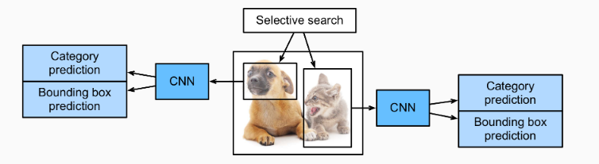Fig 1.1: R-CNN model.

Specifically, R-CNNs are composed of four main parts:

1. Selective search is performed on the input image to select multiple high-quality proposed regions. These proposed regions are generally selected on multiple scales and have different shapes and sizes. The category and ground-truth bounding box of each proposed region is labeled.
2. A pre-trained CNN is selected and placed, in truncated form, before the output layer. It transforms each proposed region into the input dimensions required by the network and uses forward computation to output the features extracted from the proposed regions.
3. The features and labeled category of each proposed region are combined as an example to train multiple support vector machines for object classification. Here, each support vector machine is used to determine whether an example belongs to a certain category.
4. The features and labeled bounding box of each proposed region are combined as an example to train a linear regression model for ground-truth bounding box prediction.

Although R-CNN models use pre-trained CNNs to effectively extract image features, the main downside is the slow speed. As you can imagine, we can select thousands of proposed regions from a single image, requiring thousands of forward computations from the CNN to perform object detection. This massive computing load means that R-CNNs are not widely used in actual applications.

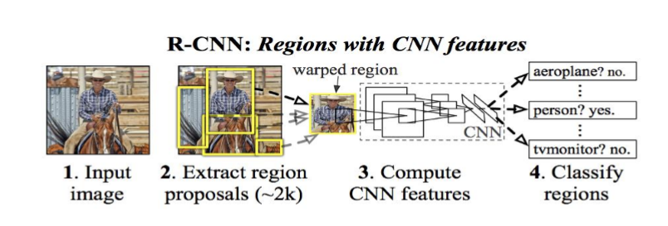

Problems of R-CNN

* Extremely slow as it takes huge amount of time to train the model.
* Impossible to implement in real time as it takes around 47 seconds to test an image.

**FAST R-CNN**

Some of the problems of R-CNN were solved to form the better version Fast R-CNN. The approach is similar to the R-CNN algorithm. But, instead of feeding the region proposals to the CNN, we feed the input image to the CNN to generate a convolutional feature map. From the convolutional feature map, we can identify the region of the proposals and warp them into the squares and by using an ROL pooling layer we reshape them into the fixed size so that it can be fed into a fully connected layer. From the ROL feature vector, we can use a softmax layer to predict the class of the proposed region and also the off set values for the bounding box.

The reason “Fast R-CNN” is faster than R-CNN is because you don’t have to feed 2000 region proposals to the convolutional neural network every time. Instead, the convolution operation is always done only once per image and a feature map is generated from it.

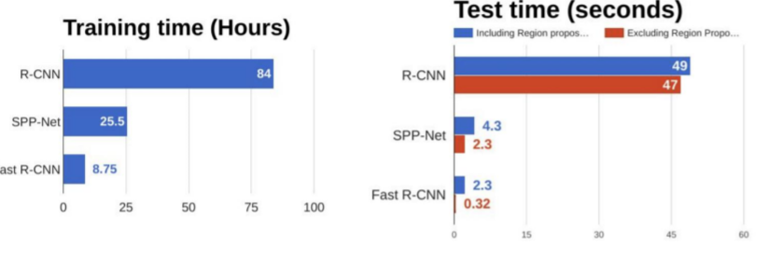Comparison between R-CNN and Fast R-CNN

**Faster R-CNN**

Faster R-CNN is composed of the following layers

**Part 1 : Convolution layers**

In this layers we train filters to extract the appropriate features from the image

* **Part 2 : Region Proposel Network (RPN)**

RPN is small neural network sliding on the last feature map of the convolution layers and predict whether there is an object or not and also predict the bounding box of those objects.

* **Part 3 : Classes and Bounding Boxes prediction**

Now we use another Fully connected neural networks that takes as an inpt the regions proposed by the RPN and predict object class (classification) and Bounding boxes (Regression).

* **Training**

To train this architecture, we use SGD to optimize convolution layers filters, RPN weights and the last fully connected layer weights.

Faster R-CNN is a network that does object detection. As explained by its name, its faster than its descendants R-CNN and Fast R-CNN. How fast? Almost real time fast. This network has use cases in self-driving cars, manufacturing, security, and is even used at Pinterest.

**How Faster RCNN works:**  
1) Run the image through a CNN to get a **Feature Map**  
2) Run the Activation Map through a separate network, called the Region Proposal Network(RPN), that outputs interesting boxes/regions  
3) For the interesting boxes/regions from RPN use several fully connected layer to output class + Bounding Box coordinates

The difference here is that Faster RCNN solved the bottleneck of having to run Selective Search for each image as the first step. Most implementations of Selective Search are on the CPU(slow) and it’s essentially a separate algorithm, so let’s get rid of it!

The intuition is that: With Faster R-CNN we’re already computing an Activation Map in the CNN, why not run the Activation Map through a few more layers to find the interesting regions, and then finish off the forward pass by predicting the classes + bbox coordinates?

**YOLO-You Only Look Once**

It is a PASCAL based technique. Prior detection systems repurpose classifiers or localizers to perform detection. They apply the model to an image at multiple locations and scales. High scoring regions of the image are considered detections.

YOLO uses a totally different approach. It applies a single neural network to the full image. This network divides the image into regions and predicts bounding boxes and probabilities for each region. These bounding boxes are weighted by the predicted probabilities.

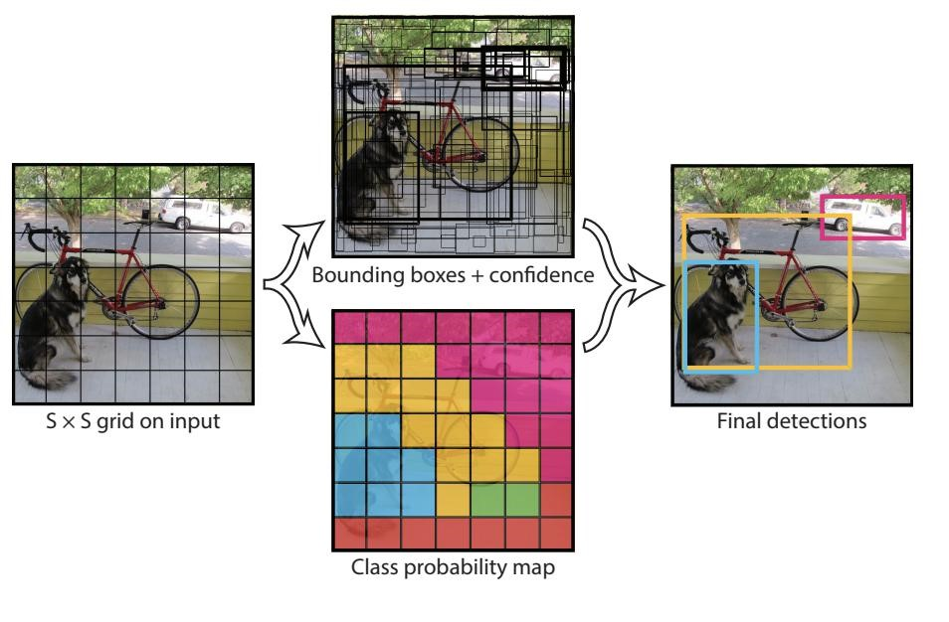

**5.1 Why YOLO?**

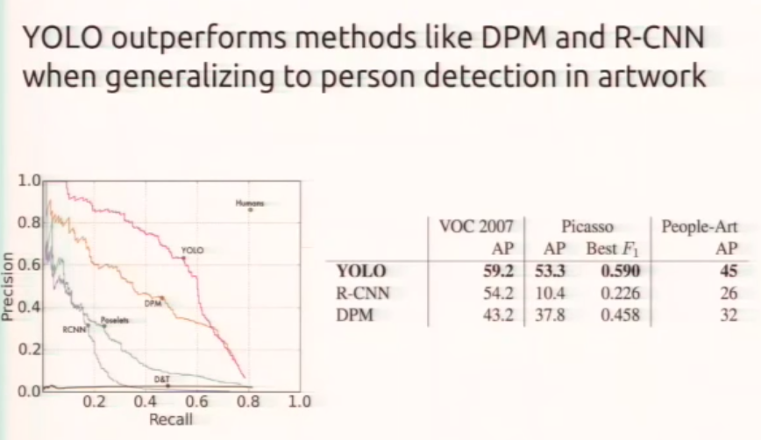

We have selected YOLO above all the models as it has drastically outperforms others.

**5.2 How Does YOLO Work?**

Unlike other models which looks at a image thousands of times YOLO as the name suggests “You Only Look Once” looks at a image only once. This saves a lot of time. This is achieved by taking a totally different approach. Which is a as follows:

1. The image is split into grids.

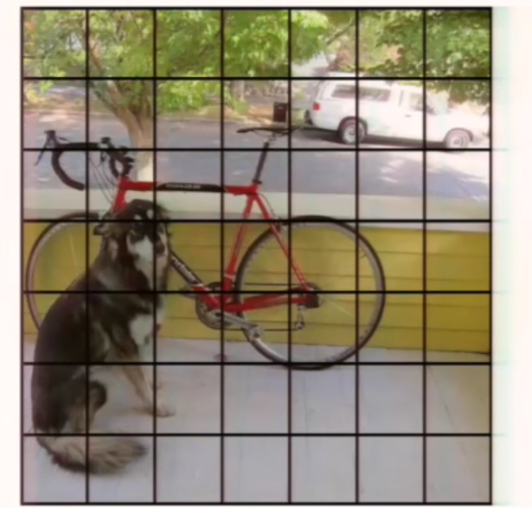

1. Each of these grids predict some number of bounding boxes and confidence values for these bounding boxes.

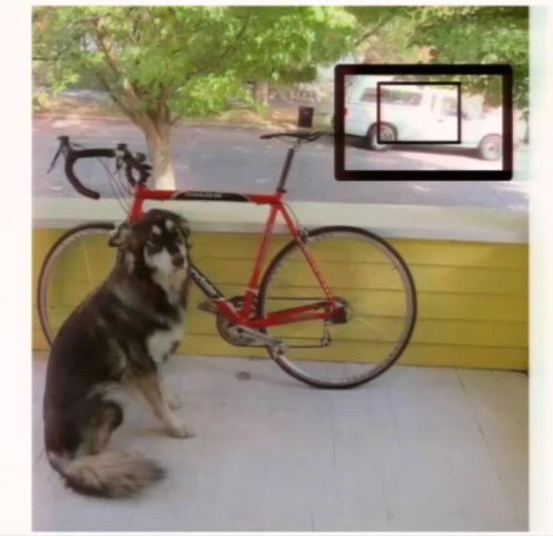

1. After this according to the confidence values the all bounding boxes are ranked in the image. This gives the system an insight where the objects are present in the image.

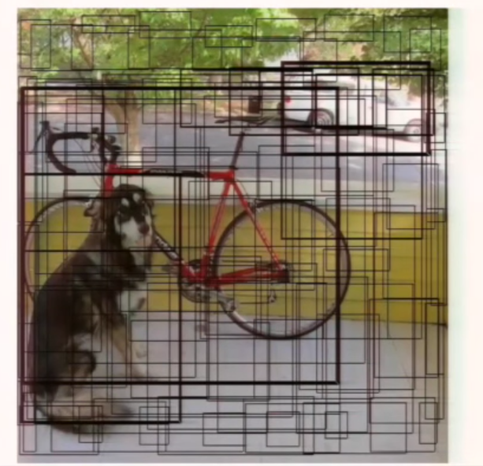

1. This is how the image looks after the region of objects are differentiated in the image.

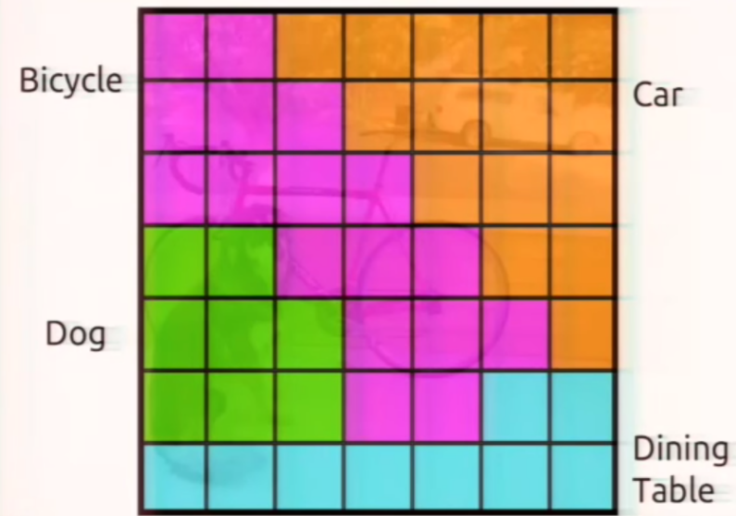

1. After this NMS(Non-Maximum Suppression) and threshold detections are implemented to limit the final object bounding boxes.

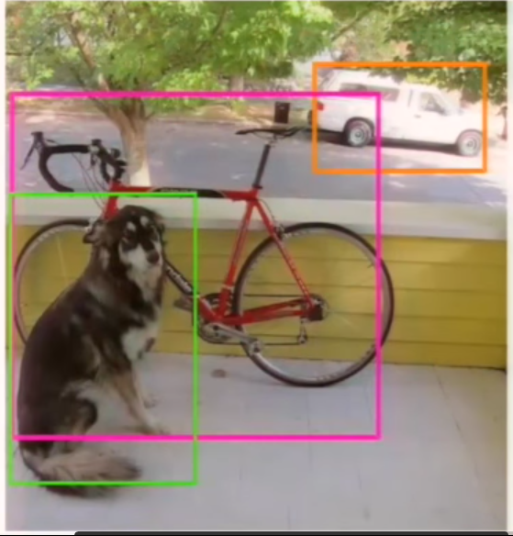

**5.3 Model Training**

During project training the centre of the object is marked and is set for detection.

The bounding boxes are adjusted such that the confidence value is increased.

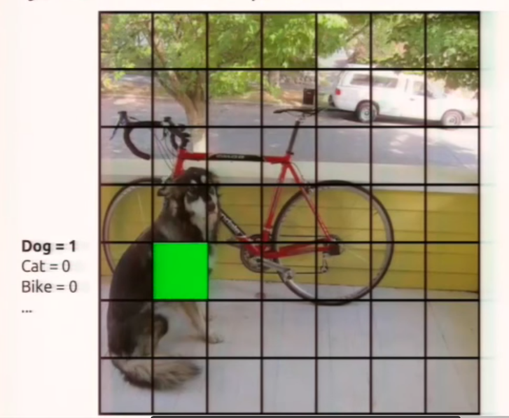

**Problem Statement**

Object Detection has been a very simple and easy task for humans but computers have struggled in this simple task. Also most of the available systems are extremely complex, time taking and expensive. In this project, we have done research to analyse the available models and select the most effective, accurate and affordable model. The training dataset used in this model is of the COCO which is of about 47GB.

**Project Methodology**

**7.1 Methodologies Used To Analyse The Above Problem:**

* A lot of research and different model analysis and study was is done to select the model which is practically possible as the resources are limited.
* After all the analysis the model was selected and Cloud services were selected over physical hardware due to the following reasons:

1. Cheaper and affordable.

2. Maintainability

3. Reliable

* The Google Colab Notebook was selected to be used as it is provide free Tesla K80 GPU and total 12 GB ram.
* The model to be used was selected as YOLO with DarkNet.

**7 .2 Reduction Of The Time**

* The model training requires huge amount of time to train so pretrained model of YOLO V3 was decided to be used as this trained model is more reliable as it has used COCO image dataset and trained with high processing systems.
* In helper function cast gradient is used where as other model use multiple other complex calculations.
* This model only looks at an image only once so it saves huge amount of time and processing.
* GoogleNet

VGG16 requires 30.69 billion floating point operations for a single pass over a 224 × 224 image versus 8.52 billion operations for a customized GoogLeNet. VGG16 was replaced with the customized GoogLeNet. However, YOLO pays a price on the top-5 accuracy for ImageNet: accuracy drops from 90.0% to 88.0%.

* **DarkNet**

Further simplifying the backbone CNN used. DarkNet requires 5.58 billion operations only. With DarkNet, YOLO achieves 72.9% top-1 accuracy and 91.2% top-5 accuracy on ImageNet. DarkNet uses mostly 3 × 3 filters to extract features and 1 × 1 filters to reduce output channels. It also uses global average pooling to make predictions. Here is the detail network description:

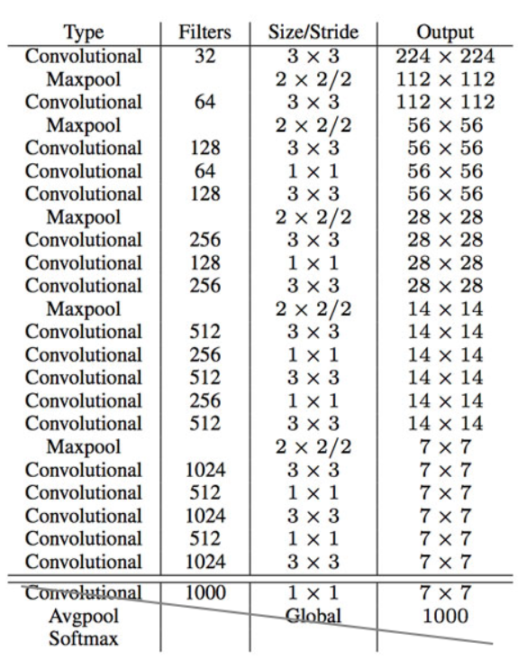

**Definitions and Tools Used**

**8.1 Convolution Layers**

Here, Convolution layer and sliding windows is explained. Firstly, let us analyse how we can convert the fully connected layers of the network into convolutional layers. This figure shows a simple convolutional network with two fully connected layer search of shape.

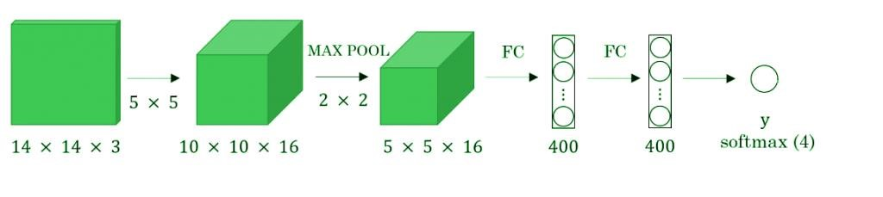

Figure 2.

Fully connected layer is converted to a convolution layer with the help of a 1D convolutional layer. The height and width of this layer is one and the number of filters are equal to the fully connected layer. The image below is an example.

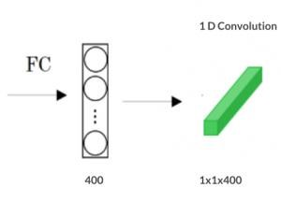

Figure 3.

We can apply the concept of conversion of a fully connected layer into a convolutional layer to the model by replacing the fully connected layer with a 1-D convolutional layer. The number of filters of the 1D convolutional layer is equal to the shape of the fully connected layer. This representation is shown in the Fig 4. Also, the outputs of softmax layer is also a convolutional layer of shape (1, 1, 4), where 4 is the number of classes to predict.

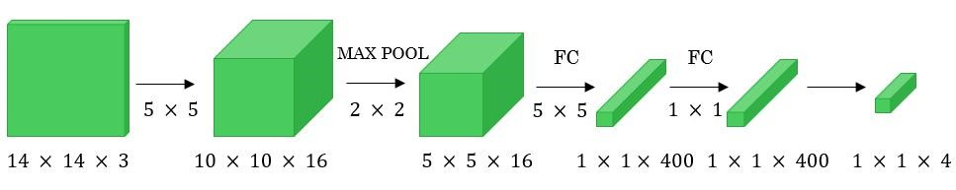

Figure 4.

Now, let’s extend the above approach to implement a convolutional version of the sliding window. First, let us consider the ConvNet that we have trained to be in the following representation (no fully connected layers).

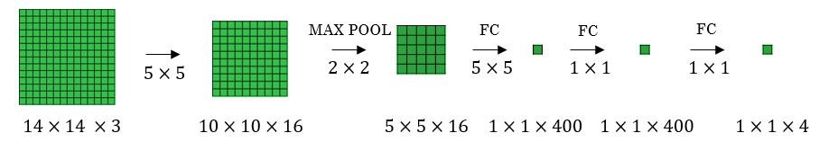

Figure 5.

Let’s assume the size of the input image to be 16 × 16 × 3. If we are using the sliding window approach, then we would have passed this image to the above ConvNet four times, where each time the sliding window crops the part of the input image matrix of size 14 × 14 × 3 and pass it through the ConvNet. But instead of this, we feed the full image (with shape 16 × 16 × 3) directly into the trained ConvNet (see Fig. 6). The result will give an output matrix of shape 2 × 2 × 4. Each cell in the output matrix represents the result of the possible crop and the classified value of the cropped image. For example, the left cell of the output matrix(the green one) in Fig. 6 represents the result of the first sliding window. The other cells in the matrix represent the results of the remaining sliding window operations.

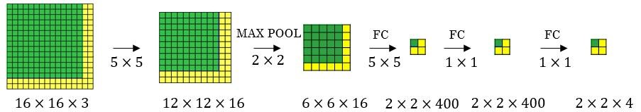

Figure 6.

The stride of the sliding window is decided by the number of filters used in the Max Pool layer. In the example above, the Max Pool layer has two filters, and for the result, the sliding window moves with a stride of two resulting in four possible outputs to the given input. The main advantage of using this technique is that the sliding window runs and computes all values simultaneously. Consequently, this technique is really fast. The weakness of this technique is that the position of the bounding boxes is not very accurate.

A better algorithm that tackles the issue of predicting accurate bounding boxes while using the convolutional sliding window technique is the [YOLO](https://arxiv.org/abs/1506.02640) [algorithm](https://arxiv.org/abs/1506.02640). YOLO stands for you only look once which was developed in 2015 by Joseph Redmon, Santosh Divvala, Ross Girshick, and Ali Farhadi. It is popular because it achieves high accuracy while running in real-time. This algorithm requires only one forward propagation to pass through the network to make the predictions.

This algorithm divides the image into grids and then runs the image classification and localization algorithm (discussed under object localization) on each of the grid cells. For example, we can give an input image of size 256 × 256. We place a 3 × 3 grid on the image (see Fig. 7).

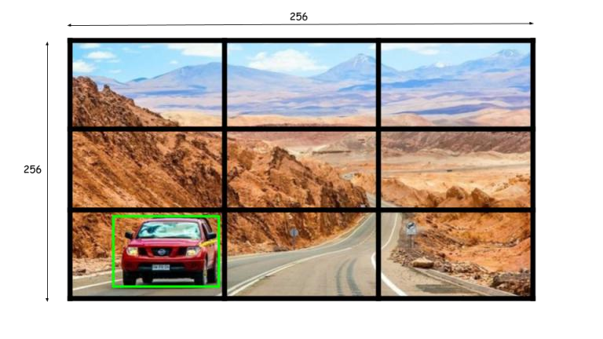

Figure 7.

Next, we shall apply the image classification and localization algorithm on each grid cell. In the image each grid cell, the target variable is defined as:

Yi, j=[pcbxbybhbwc1c2c3c4]T(6)

Since the shape of the target variable for each grid cell in the image is 1 × 9 and there are 9 (3 × 3) grid cells, the final output of the model will be:

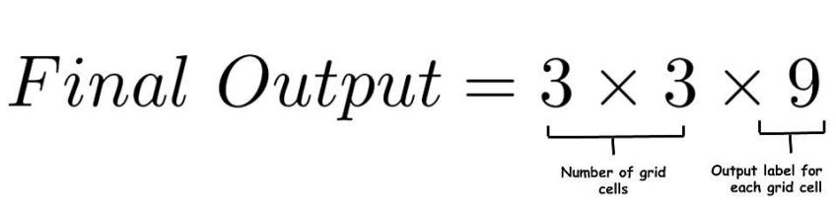

The advantages of the YOLO algorithm is that it is very fast and predicts much more accurate bounding boxes. Also, in practice to get the more accurate predictions, we use a much finer grid, say 19 × 19, in which case the target output is of the shape 19 × 19 × 9.

**8.2 System Requirements**

1. A 64bit Windows 10 system.
2. At least 3GB of free space.
3. Internet connection with at least 8.45Mbps.
4. Google Drive Account is required.
5. GitHub Account is required.
6. Camera is required to capture pictures.

**8.3 Development Tools Used**

|  |  |  |
| --- | --- | --- |
| Software Used | Version | Usage |
| Microsoft Windows (OS) | 10(1909) | Operating System. |
| Google-Colab Notebook | 1.0.0 | Used for implementation of model, google provides cloud GPU and Storage. |
| Google-Drive | 2.20.141.03.44 | Provides Cloud Storage for images to be detected. |
| GitHub | 2.20.5 | Store the source code weights and Dataset. |
| COCO | 1 | It is a large set of images which is used to train model. |
| YOLO | V3 | Used to classify the image class. |
| DarkNet | 1.0 | Framework used to train neural network. |
| OPENCV | 4.2.0 | Library used for image processing. |
| TensorFlow | 2.10 | Library used to for numerical computation. |
| Numpy | 1.16.1 | Used for mathematical operations. Like here cast gradient is used. |
| Python | 3.6.5 | Used for writing source code. |

**Implementation**

**Basic First layer filters Applied of convolution layer**

**Horizontal Filter**

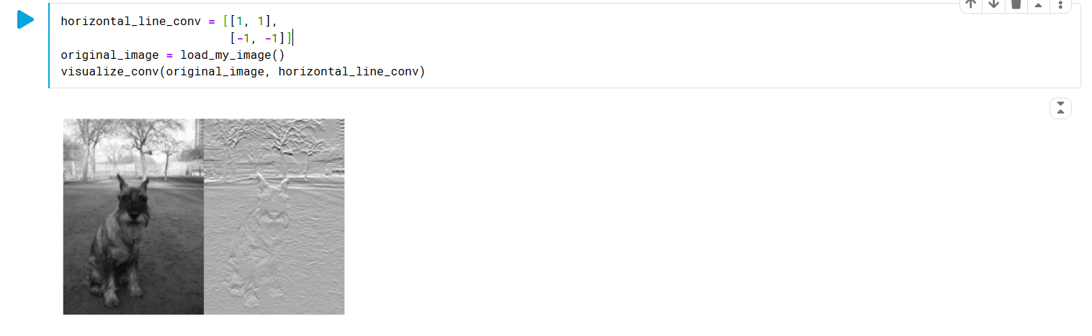

**Vertical Filter**

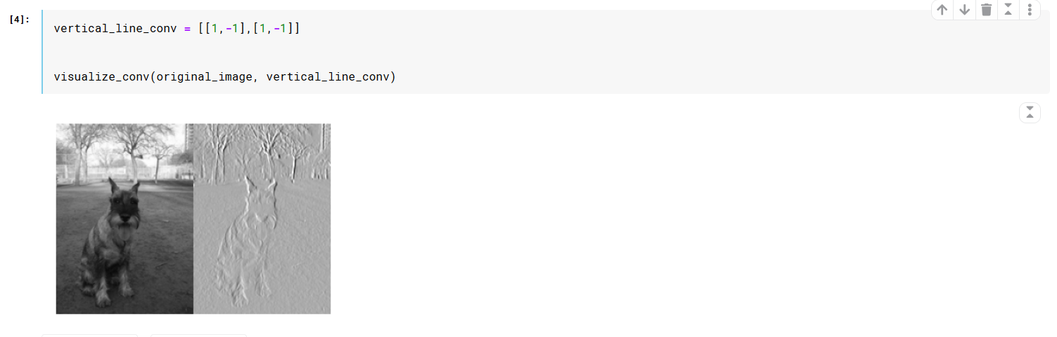

**YOLO MODEL SOURCE CODE**

**9.1 Steps:**

1. Cloning the DarkNet repository to our Colab notebook.
2. Enabling OPENCV and GPU.
3. Enabling CUDA compiler driver.
4. Build DarkNet model.
5. Download pre-trained YOLO V3 weights.(Pre-trained model used)
6. Helper functions are defined.
7. Detection is executed and image is shown using helper function.
8. Google Drive is linked to the Notebook.
9. The extension of the image is provided and detection is run.

**9.2 Source Code**

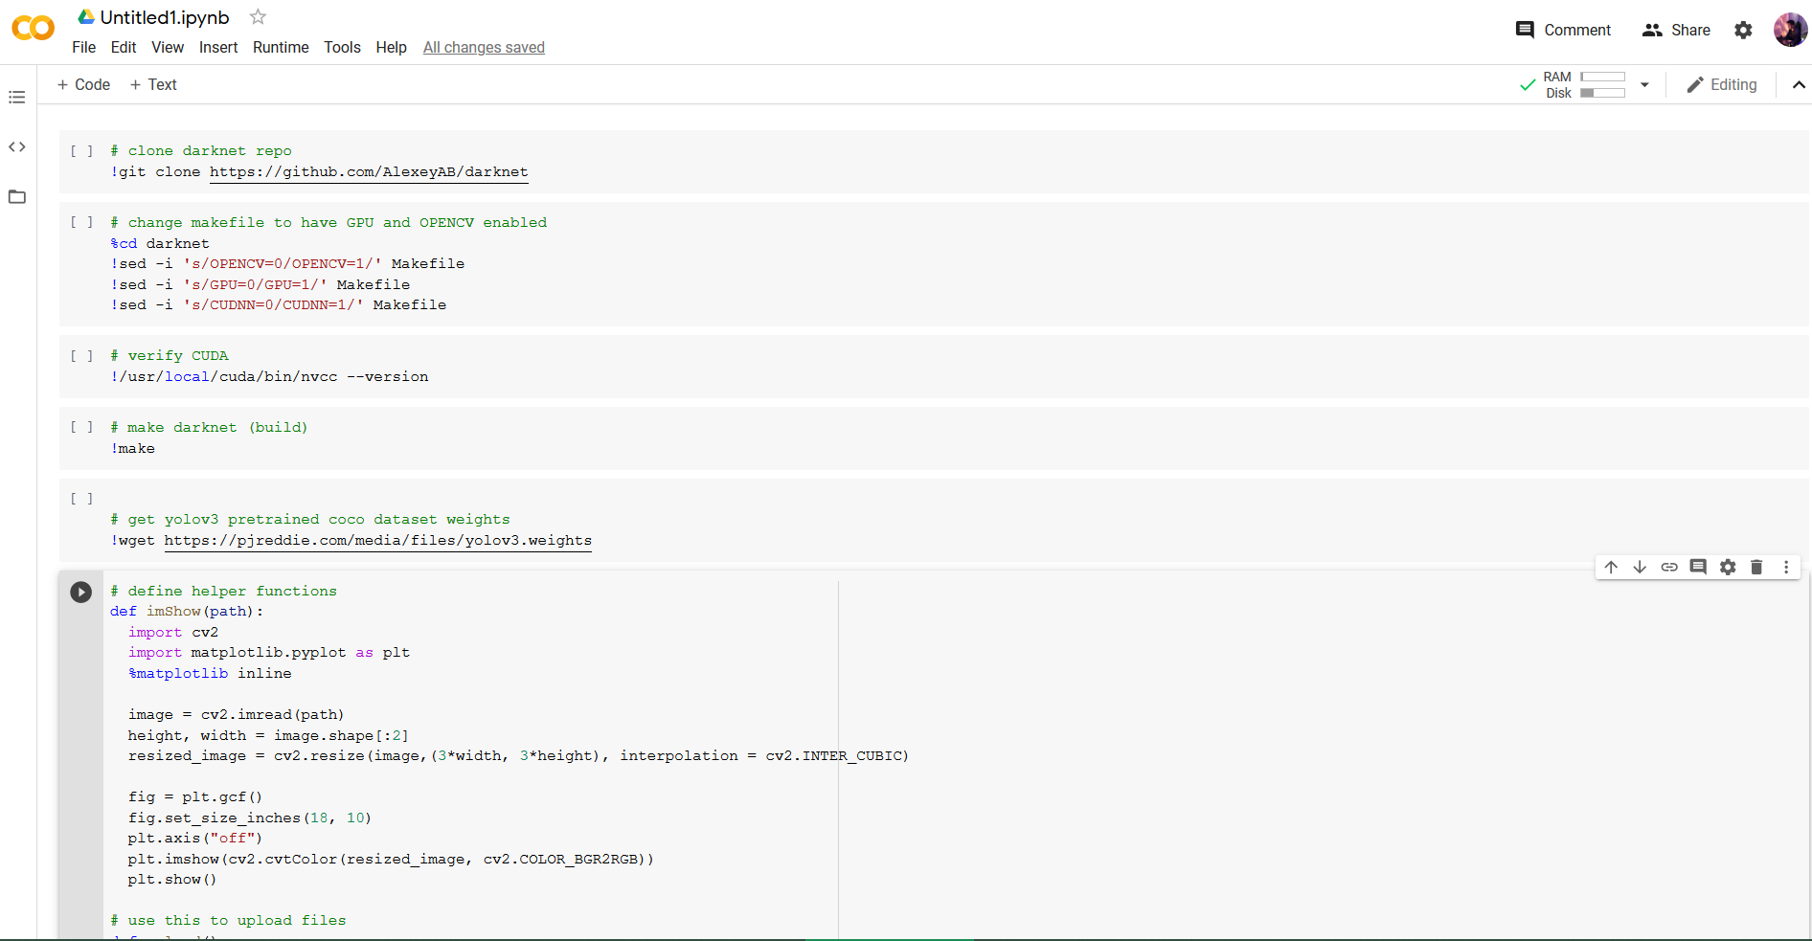

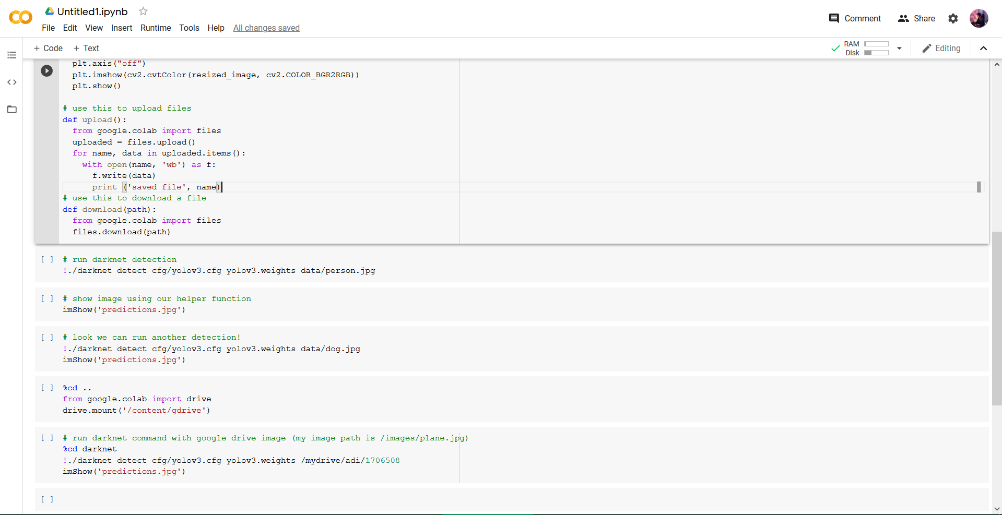

**Performance Measures Of Models**

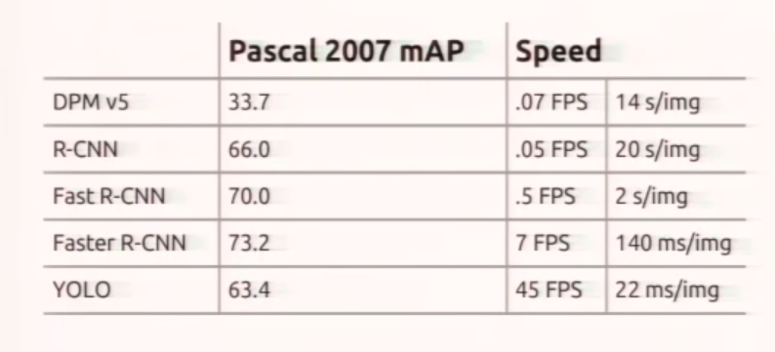

These are the performances of all the models .It is known that model with FPS below 10 cannot be used in Self Driving cars, CCTVs and other applications as they are too slow.

**Results and Conclusion**

**11.1 Snapshots**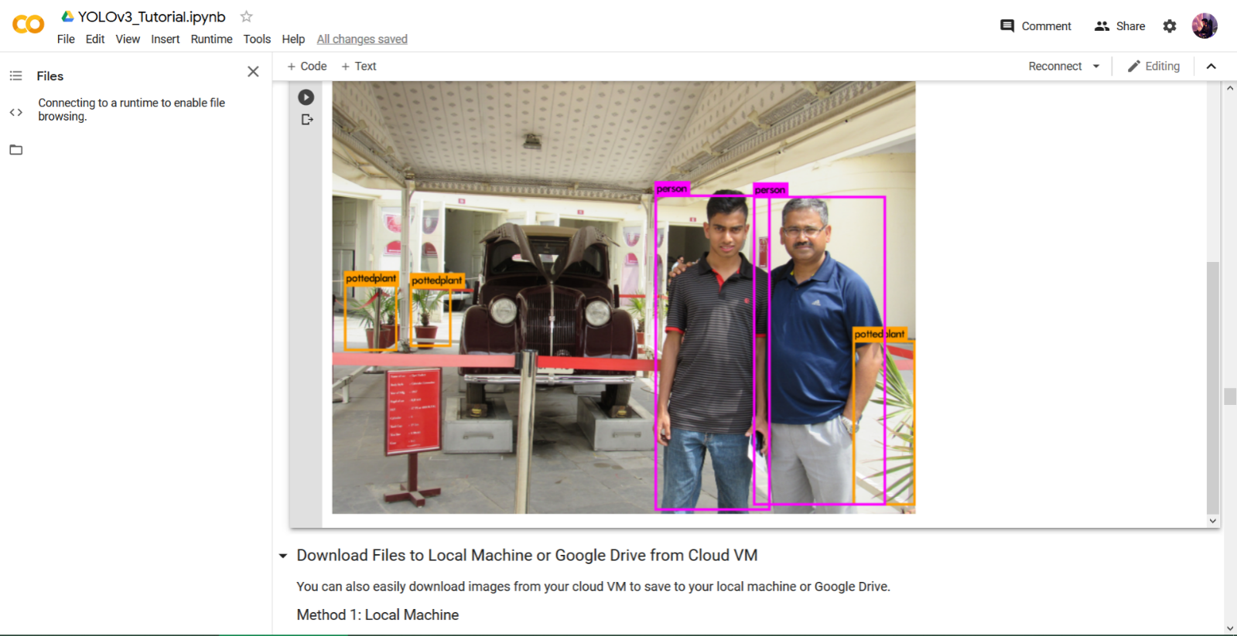

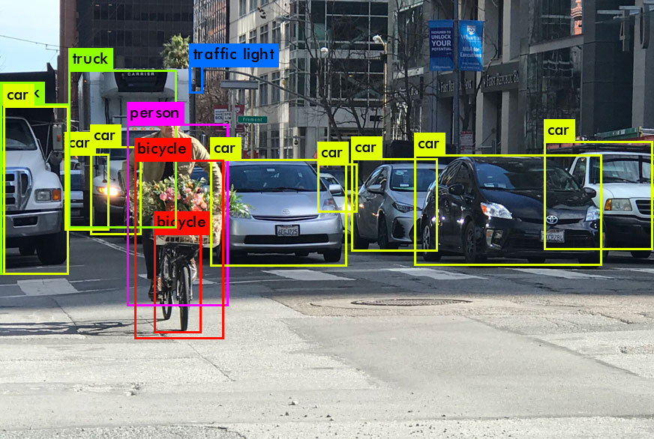

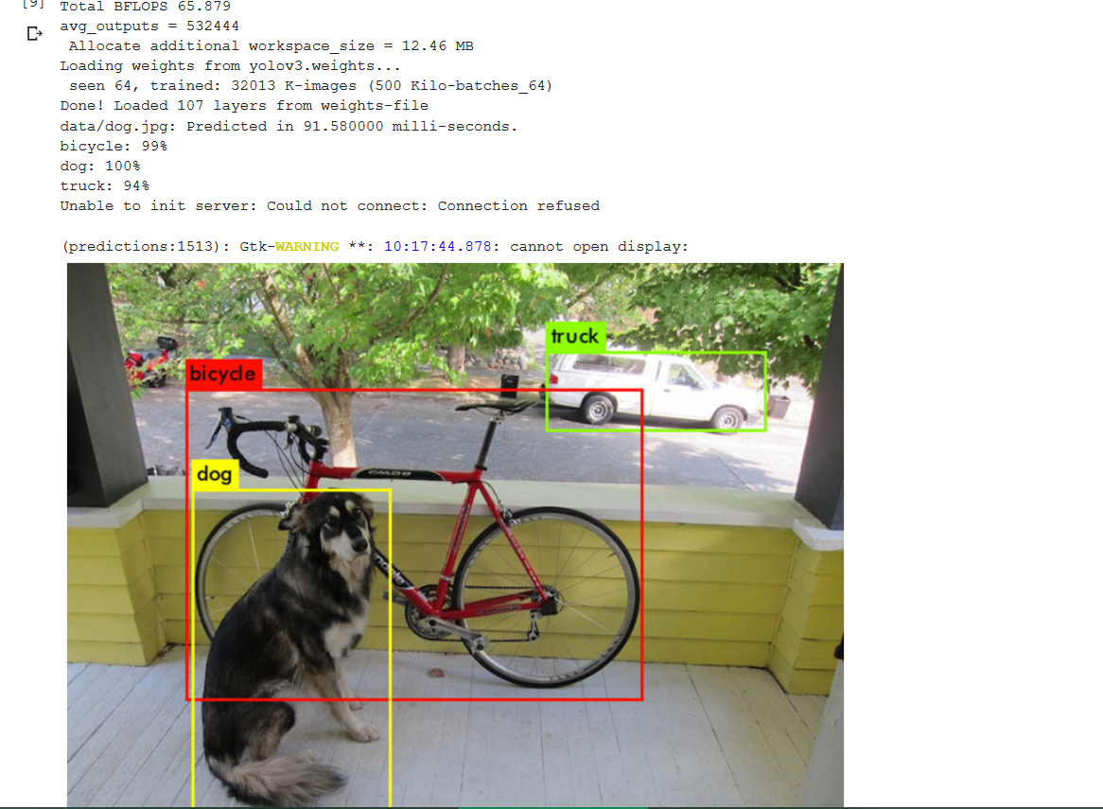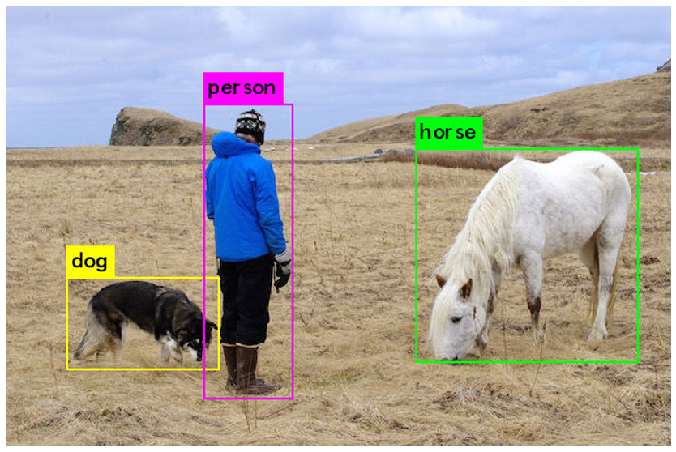

**11.2 Future Scope**

This model provides 45 -68fps so can be implemented to detect live videos as well. Object detection is one of the key abilities required by most computer vision and robot vision systems. Finally, we need to consider that we will need object detection systems for nano -robots or for robots that will explore areas that have not been seen by humans, such as deep parts of the sea or other planets, and the detection systems will have to learn to detect new object classes as they are encountered. The following enhancements can be made :

* With the help of physical GPU rather than cloud GPU object detection can be run on live videos.
* Efficiency of the object detection can be increased.
* Splitting and merging cannot be handled very well in all conditions using the single camera due to the loss of information of a 3D object projection in 2D images.
* Further we can also create a custom dataset using our images and create classes for objects which are not available in the dataset.
* YOLO is working to develop x3 version which is said to work efficiently in computers with less computational power and GPU power.

**11.3 Conclusion**

Through this project we got to know about the existing models through which computers can detect objects. Also, experimental results are that YOLO can classify images based on the class faster than all other models and with DarkNet accuracy can be improved by 91%, rest all the other models are not worth practical usage.

With some further work we can easily integrate this system and run it on live video recordings which in turn can be used in self driving cars as the model provides the information and position of the objects to the user in fraction of seconds.

**References**

1. Azizpour, H., and Laptev, I. (2012). “Object detection using strongly-superviseddeformable part models,”inComputerVision-ECCV2012(Florence:Springer),836–849.
2. Bengio, Y. (2012). “Deep learning of representations for unsupervised and transferlearning,” in ICML Unsupervised and TransferLearning, Volume27ofJMLRProceedings, edsI. Guyon, G.Dror, V.Lemaire,G.W.Taylor,andD.L.Silver(Bellevue:JMLR.Org),17–36.
3. Bourdev, L. D., and Malik, J. (2009). “Poselets: body part detectors trained using 3dhuman pose annotations,” in IEEE 12th International Conference on ComputerVision, ICCV 2009, Kyoto, Japan, September27–October4,2009(Kyoto:IEEE),1365–1372.
4. M. B. Blaschko and C. H. Lampert. Learning to localize objects with structured output regression. In Computer Vision– ECCV 2008, pages 2–15. Springer, 2008.
5. L. Bourdev and J. Malik. Poselets: Body part detectors trained using 3d human pose annotations. In International Conference on Computer Vision (ICCV), 2009.
6. P. Viola and M. Jones. Robust real-time object detection. International Journal of Computer Vision, 4:34–47, 2001.
7. P. Viola and M. J. Jones. Robust real-time face detection. International journal of computer vision, 57(2):137–154, 2004.
8. O. Russakovsky, J. Deng, H. Su, J. Krause, S. Satheesh, S. Ma, Z. Huang, A. Karpathy, A. Khosla, M. Bernstein, A. C. Berg, and L. Fei-Fei. ImageNet Large Scale Visual Recognition Challenge. International Journal of Computer Vision (IJCV), 2015
9. YOLO research papers by Joseph Redmon University of Washington, Santosh Divvala Allen Institute for Artiﬁcial Intelligence , Ross Girshick Facebook AI Research and Ali Farhadi University of Washington.
10. Kaggle Deep Learning Course.

**Sample Individual Contribution Report**

**OBJECT DETECTION**

**Aditya Sinha 1706005**

**Aishwarya Aditya 1706007**

**Mainak Basu Roy 1706049**

**Jishnu Dey 1706508**

**Abstract:** The aim of this project work is to study about the existing models present in object detection and implement the feasible one.

**Individual Contributions to project Report Preparation and findings:**

Aditya Sinha: Introduction, YOLO, YOLO Working, Implementation, Convolution Layer

Aishwarya Aditya: Literature Survey, Fast R-CNN, Faster R-CNN, Model Selection, Future Scope

Mainak Basu Roy: Abstract ,SRS, R-CNN, Problem Statement

Jishnu Dey: Res Net, Methodology, Performance, Basic Filters

**Signature Of Supervisor Signature Of Students**

Hrudaya Kumar TripathyAditya Sinha

Aishwarya Aditya

Mainak Basu Roy

Jishnu Dey